The Aftermath Game Design Document (GDD)



***“The Aftermath Awaits”* -** *Only Champs Studio*

This page: Table of Contents and Team Member Listing

|  |  |  |
| --- | --- | --- |
| Table of Contents  [1 Game Overview](https://n-xovwktmtjsnaxyc2mwes2xu7pohqedmdm6zjw5q-2lu-script.googleusercontent.com/userCodeAppPanel#)  [2 High Concept](https://n-xovwktmtjsnaxyc2mwes2xu7pohqedmdm6zjw5q-2lu-script.googleusercontent.com/userCodeAppPanel#)  [3 Unique Selling Points](https://n-xovwktmtjsnaxyc2mwes2xu7pohqedmdm6zjw5q-2lu-script.googleusercontent.com/userCodeAppPanel#)  [4 Platform Minimum Requirements](https://n-xovwktmtjsnaxyc2mwes2xu7pohqedmdm6zjw5q-2lu-script.googleusercontent.com/userCodeAppPanel#)  [5 Competitors / Similar Titles](https://n-xovwktmtjsnaxyc2mwes2xu7pohqedmdm6zjw5q-2lu-script.googleusercontent.com/userCodeAppPanel#)  [6 Synopsis](https://n-xovwktmtjsnaxyc2mwes2xu7pohqedmdm6zjw5q-2lu-script.googleusercontent.com/userCodeAppPanel#)  [7 Game Objectives](https://n-xovwktmtjsnaxyc2mwes2xu7pohqedmdm6zjw5q-2lu-script.googleusercontent.com/userCodeAppPanel#)  [8 Game Rules](https://n-xovwktmtjsnaxyc2mwes2xu7pohqedmdm6zjw5q-2lu-script.googleusercontent.com/userCodeAppPanel#)  [9 Game Structure](https://n-xovwktmtjsnaxyc2mwes2xu7pohqedmdm6zjw5q-2lu-script.googleusercontent.com/userCodeAppPanel#)  [10 Game Play](https://n-xovwktmtjsnaxyc2mwes2xu7pohqedmdm6zjw5q-2lu-script.googleusercontent.com/userCodeAppPanel#)  [10.1 Game Controls](https://n-xovwktmtjsnaxyc2mwes2xu7pohqedmdm6zjw5q-2lu-script.googleusercontent.com/userCodeAppPanel#)  [10.2 Game Camera](https://n-xovwktmtjsnaxyc2mwes2xu7pohqedmdm6zjw5q-2lu-script.googleusercontent.com/userCodeAppPanel#)  [10.2.1 HUD](https://n-xovwktmtjsnaxyc2mwes2xu7pohqedmdm6zjw5q-2lu-script.googleusercontent.com/userCodeAppPanel#)  [10.2.2 Maps](https://n-xovwktmtjsnaxyc2mwes2xu7pohqedmdm6zjw5q-2lu-script.googleusercontent.com/userCodeAppPanel#)  [11 Players](https://n-xovwktmtjsnaxyc2mwes2xu7pohqedmdm6zjw5q-2lu-script.googleusercontent.com/userCodeAppPanel#)  [11.1 Characters](https://n-xovwktmtjsnaxyc2mwes2xu7pohqedmdm6zjw5q-2lu-script.googleusercontent.com/userCodeAppPanel#)  [11.2 Metrics](https://n-xovwktmtjsnaxyc2mwes2xu7pohqedmdm6zjw5q-2lu-script.googleusercontent.com/userCodeAppPanel#)  [11.3 States](https://n-xovwktmtjsnaxyc2mwes2xu7pohqedmdm6zjw5q-2lu-script.googleusercontent.com/userCodeAppPanel#)  [11.4 Weapons](https://n-xovwktmtjsnaxyc2mwes2xu7pohqedmdm6zjw5q-2lu-script.googleusercontent.com/userCodeAppPanel#)  [12 Player Line-up](https://n-xovwktmtjsnaxyc2mwes2xu7pohqedmdm6zjw5q-2lu-script.googleusercontent.com/userCodeAppPanel#)  [13 NPC](https://n-xovwktmtjsnaxyc2mwes2xu7pohqedmdm6zjw5q-2lu-script.googleusercontent.com/userCodeAppPanel#)  [13.1 Enemies](https://n-xovwktmtjsnaxyc2mwes2xu7pohqedmdm6zjw5q-2lu-script.googleusercontent.com/userCodeAppPanel#)  [13.1.1 Enemy States](https://n-xovwktmtjsnaxyc2mwes2xu7pohqedmdm6zjw5q-2lu-script.googleusercontent.com/userCodeAppPanel#)  [13.1.2 Enemy Spawn Points](https://n-xovwktmtjsnaxyc2mwes2xu7pohqedmdm6zjw5q-2lu-script.googleusercontent.com/userCodeAppPanel#)  [13.2 Allies / Companions](https://n-xovwktmtjsnaxyc2mwes2xu7pohqedmdm6zjw5q-2lu-script.googleusercontent.com/userCodeAppPanel#)  [13.2.1 Ally States](https://n-xovwktmtjsnaxyc2mwes2xu7pohqedmdm6zjw5q-2lu-script.googleusercontent.com/userCodeAppPanel#)  [13.2.2 Ally Spawn Points](https://n-xovwktmtjsnaxyc2mwes2xu7pohqedmdm6zjw5q-2lu-script.googleusercontent.com/userCodeAppPanel#)  [14 Art](https://n-xovwktmtjsnaxyc2mwes2xu7pohqedmdm6zjw5q-2lu-script.googleusercontent.com/userCodeAppPanel#)  [14.1 Setting](https://n-xovwktmtjsnaxyc2mwes2xu7pohqedmdm6zjw5q-2lu-script.googleusercontent.com/userCodeAppPanel#)  [14.2 Level Design](https://n-xovwktmtjsnaxyc2mwes2xu7pohqedmdm6zjw5q-2lu-script.googleusercontent.com/userCodeAppPanel#)  [14.3 Audio](https://n-xovwktmtjsnaxyc2mwes2xu7pohqedmdm6zjw5q-2lu-script.googleusercontent.com/userCodeAppPanel#)  [15 Procedurally Generated Content](https://n-xovwktmtjsnaxyc2mwes2xu7pohqedmdm6zjw5q-2lu-script.googleusercontent.com/userCodeAppPanel#)  [15.1 Environment](https://n-xovwktmtjsnaxyc2mwes2xu7pohqedmdm6zjw5q-2lu-script.googleusercontent.com/userCodeAppPanel#)  [15.2 Levels](https://n-xovwktmtjsnaxyc2mwes2xu7pohqedmdm6zjw5q-2lu-script.googleusercontent.com/userCodeAppPanel#)  [15.3 Artificial Intelligence NPC](https://n-xovwktmtjsnaxyc2mwes2xu7pohqedmdm6zjw5q-2lu-script.googleusercontent.com/userCodeAppPanel#)  [15.4 Visual Arts](https://n-xovwktmtjsnaxyc2mwes2xu7pohqedmdm6zjw5q-2lu-script.googleusercontent.com/userCodeAppPanel#)  [15.5 Audio](https://n-xovwktmtjsnaxyc2mwes2xu7pohqedmdm6zjw5q-2lu-script.googleusercontent.com/userCodeAppPanel#)  [15.6 Minimum Viable Product (MPV)](https://n-xovwktmtjsnaxyc2mwes2xu7pohqedmdm6zjw5q-2lu-script.googleusercontent.com/userCodeAppPanel#)  [16 Wish List](https://n-xovwktmtjsnaxyc2mwes2xu7pohqedmdm6zjw5q-2lu-script.googleusercontent.com/userCodeAppPanel#)   |  | | --- | |  | | Game Development Team Members    PRODUCERS  Reymond Pamelar, Tyler Nguyen, Reian Festejo, Sam Hsu    PRODUCTION MANAGERS  Reymond Pamelar, Tyler Nguyen, Reian Festejo, Sam Hsu    PRODUCTION COORDINATOR  Reymond Pamelar, Tyler Nguyen, Reian Festejo, Sam Hsu  GAME DESIGNERS  Reymond Pamelar, Tyler Nguyen, Reian Festejo, Sam Hsu  SYSTEMS/IT COORDINATOR  Reymond Pamelar, Tyler Nguyen, Reian Festejo, Sam Hsu  PROGRAMMERS  Reymond Pamelar, Tyler Nguyen, Reian Festejo, Sam Hsu  TECHNICAL ARTISTS  Reymond Pamelar, Tyler Nguyen, Reian Festejo, Sam Hsu  AUDIO ENGINEERS  Sam Hsu, Reymond Pamelar  UX TESTERS  Reymond Pamelar, Tyler Nguyen, Reian Festejo, Sam Hsu |

|  |
| --- |
|  |

# 1 Game Overview

Title: The Aftermath

Platform: PC Standalone

Genre: Top-down shooter, hack-and-slash

Rating: (10+) ESRB

Target: Mature gamer (17+)

Release date: December, 2020

Publisher: Only Champs Studio

Description: It will take place in an unknown environment filled with dangerous entities. Play as a swordsman who must survive through an endless horde of humanoid creatures. Enemies will appear at random points across the terrain, and the soldier must defend himself against the endless horde. Tread carefully however, as the soldier has a finite amount of health that can be taken away by the enemies. Welcome to the Aftermath.

# 2 High Concept

Fear. An instinct that can drive you insane or make you more alert and focused. In The Aftermath, you play as a swordsman who has to fend off invaders for as long as possible. There’s no telling where the enemies will spawn or how many will chase after you. As you slash away at the creatures, you will notice the eerie background music and unsettling terrains, evoking a feeling of uneasiness and fear. Will you use this fear to your advantage, or let it lead you to your downfall?

# 3 Unique Selling Points

* Survival
* Close quarter battles
* Hordes of enemies at once

# 4 Platform Minimum Requirements

# **PC, MAC AND LINUX STANDALONE**

# OS: Windows 7+; card: DX9 (shader model 2.0) capabilities; generally everything made since 2004 should work

# 5 Competitors / Similar Titles

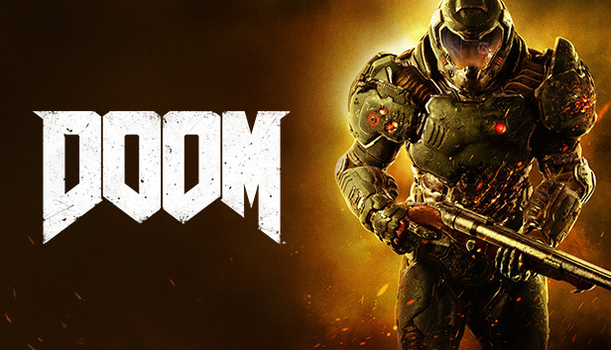

# 6 Synopsis

An anomaly exerting tremendous amounts of energy has been discovered off the coasts of Japan. As always, humanity plans on exploiting it for their own good. “Possible infinite energy to power the world!” becomes the headline that circulates the globe. It is this naive, selfishness that paints a path of events towards the unforeseen. After an experiment gone wrong, the anomaly sends a shockwave felt across the circumference of the world. Half of eastern Asia is disintegrated as well as the west coast of America; this was only the first wave. Seconds after, humanoid creatures flock from the anomaly with a hunger for humanity. However, A lone swordsman rises from the ashes having been mutated with extraordinary power. 5 years later, he still must fight to survive… in the Aftermath.

# 7 Game Objectives

1. Overcome endless waves of enemies
2. Recover health through killing enemies

# 8 Game Rules

Upon entering the game, the player starts in the middle area of the terrain. Immediately enemies are spawned and the player must defend themselves against the enemies rushing at them. The player has the freedom to move within the terrain’s boundaries to maneuver against the enemies. The player can fight against the horde using a light attack (left click) or using a dash attack (right click) that can be used after killing a set amount of enemies. The player’s kills are kept tracked in the HUD and the highest kill count will be displayed in the main menu.

# 9 Game Structure

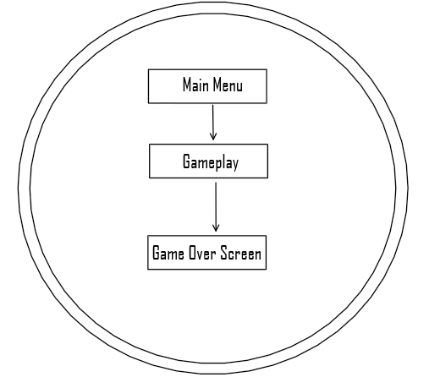

# 10 Game Play

## 10.1 Game Controls

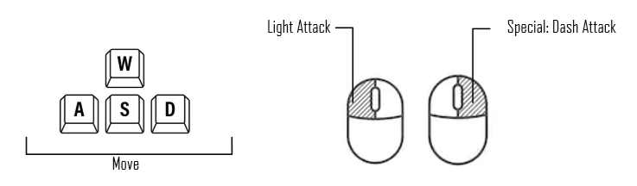

## 10.2 Game Camera

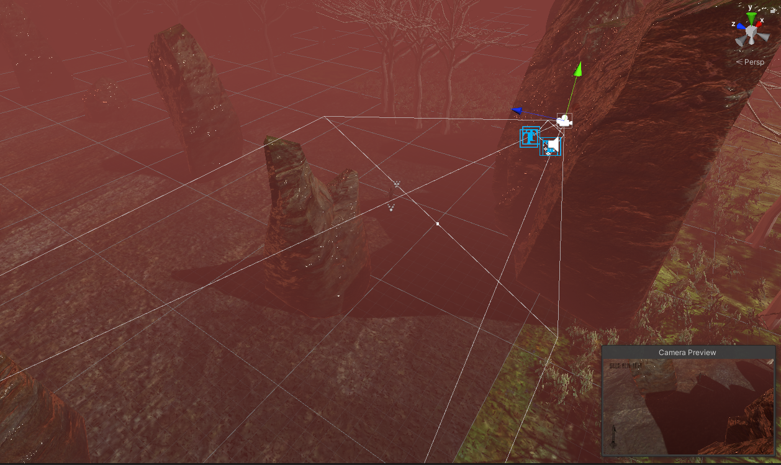

**Top-Down Perspective:**

When the game starts, the camera will move along with the player as they move throughout the map.

### 10.2.1 HUD

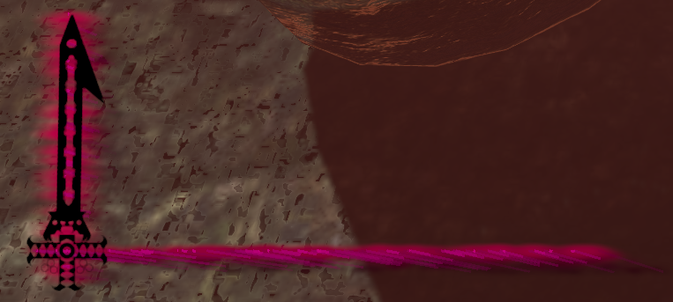

**Health and Dash Attack Cooldown**

* Health will be displayed as a health bar
* Charged sword will be displayed to indicate dash ability



**Kill Count**

* Kill count is shown on the top left

### 10.2.2 Maps

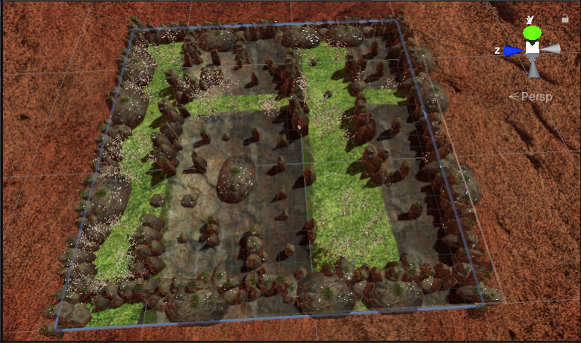

# 11 Players

## 11.1 Characters

The swordsman, whose name is unknown, is an agile, mutated human who is masterful with a sword. His otherworldly reflexes and speed powered by the anomaly, heightens his already honed sword skills to new heights

## 11.2 Metrics

* Max Health: 500
* Speed: 15
* Attack Damage: Instant-Kill

## 11.3 States

**Idle**: Triggered when no player input is given.

**Run**: Blended with idle. This state fully takes over if the player is moving at max velocity.

**Light attack 1**: Triggered from the run or idle state. The character will attack the direction they are facing. It can be blended with the run state to move and attack at the same time.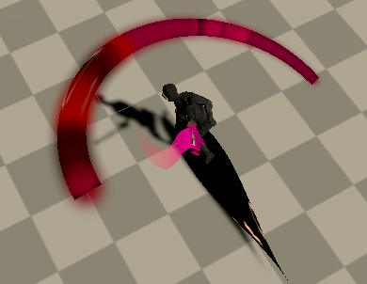

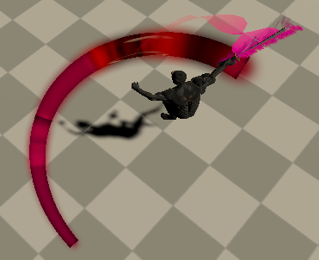

**Light attack 2**: Similar to Light attack 1. However, this state can only be triggered after Light Attack 1. Additionally, this state plays a faster animation in comparison to Light Attack 1.

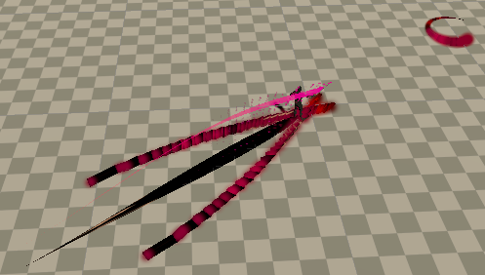

**Dash Attack**: Can only be triggered with a full meter (Indicated by the sword on the left hand side of the UI). The player will dash to the area that is clicked. Can only be interrupted by death or by a wall between the point clicked and the player.

## 11.4 Weapons

**Katana:** This is the only weapon used by the character for all attacks. It has the ability to indicate to the player when the dash attack is ready. Black will indicate that it is on cooldown while pink will indicate that it is ready to be used.

# 13 NPC

## 13.1 Enemies

Here, the enemies are known as “Hellien Slaves”. These fast, zombie-like creatures constantly get cloned as the game progresses. They continuously spawn randomly throughout the terrain, outside of the camera and die once the soldier slashes them with his sword.

### 13.1.1 Enemy States

**Idle:** The enemy triggers the idle state, for a second, once they are spawned.

**Move:** The move state is triggered after the idle state, continuously moving towards the soldier.

**Attack:** Once the enemy is close enough to reach the soldier, the attack state is constantly triggered.

**Death:** The death state is triggered once the soldier slashes the enemy with its sword.

### 13.1.2 Enemy Spawn Points

Each enemy and its clone will be constantly spawned randomly, throughout the terrain, outside of the camera.

# 14 Art

## 14.1 Setting

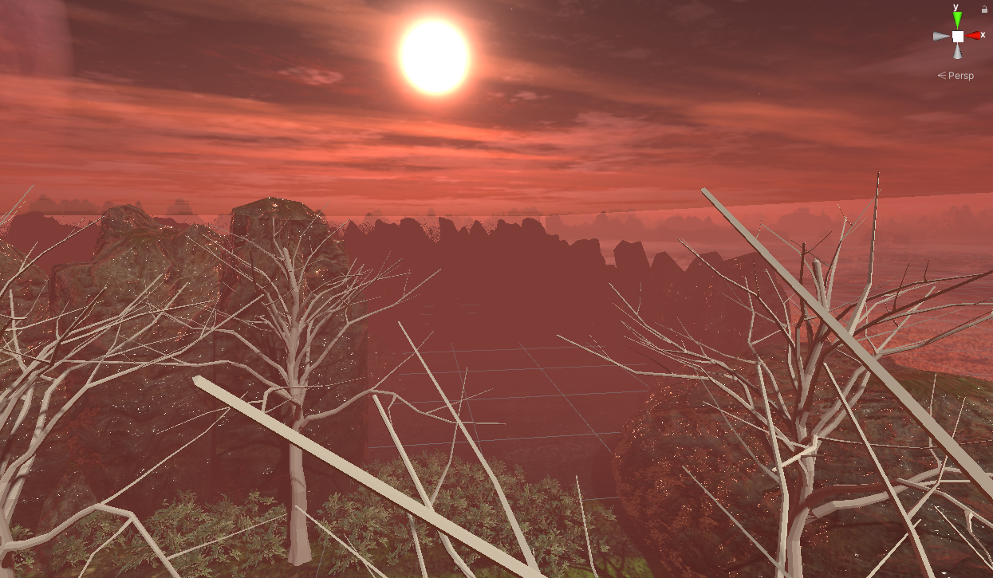

**Wasteland:**

Blanketed with fog and a reddish hue, this post-apocalyptic-like setting depicts Japan in the aftermath of the explosion from the anomaly. It is five years past the events of the explosion. Somehow, bushes have had an easier time adjusting to the change in the atmosphere than the trees.

## 14.2 Level Design

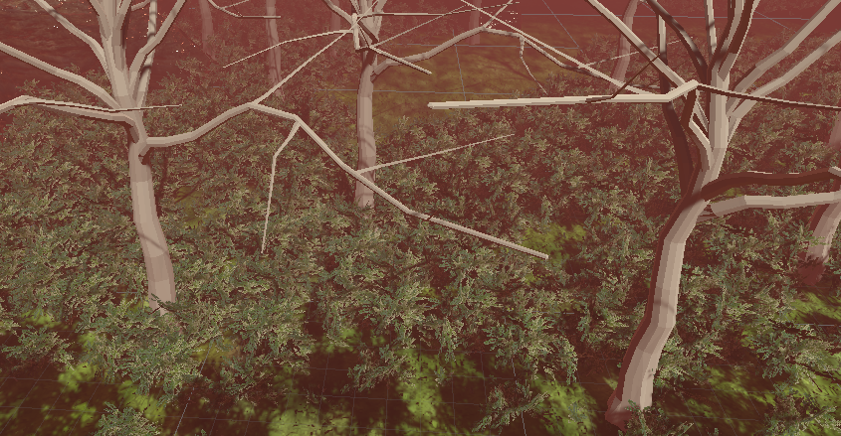

**Trees and Bushes:**

Enemy AI has a hard time maneuvering through this area. This allows the player for some breathing room. However, it also hinders the player’s sight. Enemies could be hidden between the greenery.

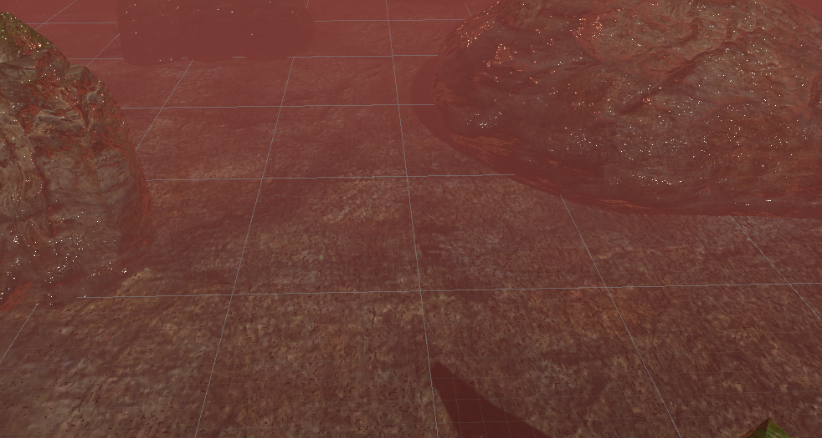

**Canyon:**

In this area of the map, the player’s view is more clear. As a trade-off, enemies are able to move around just as freely as the player.

## 14.3 Audio

Name Category Description

backgroundMusicForCS583 Background music Plays during gameplay

main menu song for CS583 Game Background music Plays in main menu

Sword-1a FX Light attack audio

PlayerDeath FX When player dies

hellien step-[AudioTrimmer.com] FX Enemy movement sounds

Cinematic-sonic-boom FX Dash attack audio

# 15 Procedurally Generated Content

## 15.3 Artificial Intelligence NPC

**Nav Mesh Agent:** The enemies utilize the Nav Mesh Agent component and utilize Unity’s AI library to move around the environment and obstacles.

## 15.6 Minimum Viable Product (MPV)

* A horde of enemies
* A player character that is able to attack multiple enemies at once

# 16 In-Game Screenshots

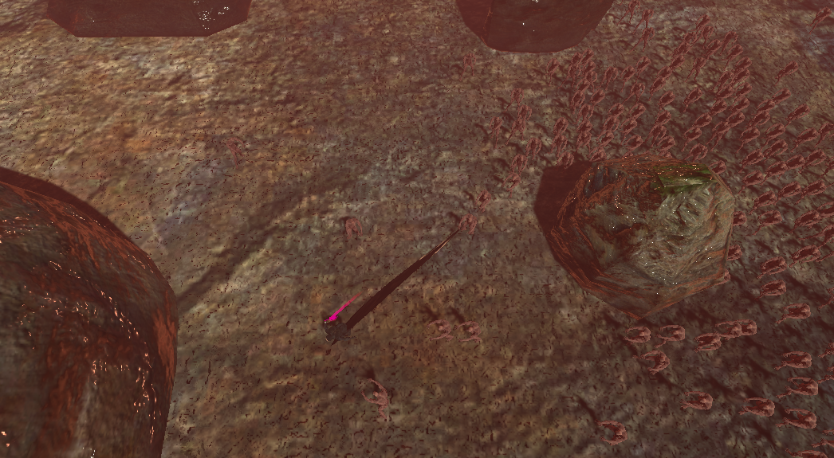

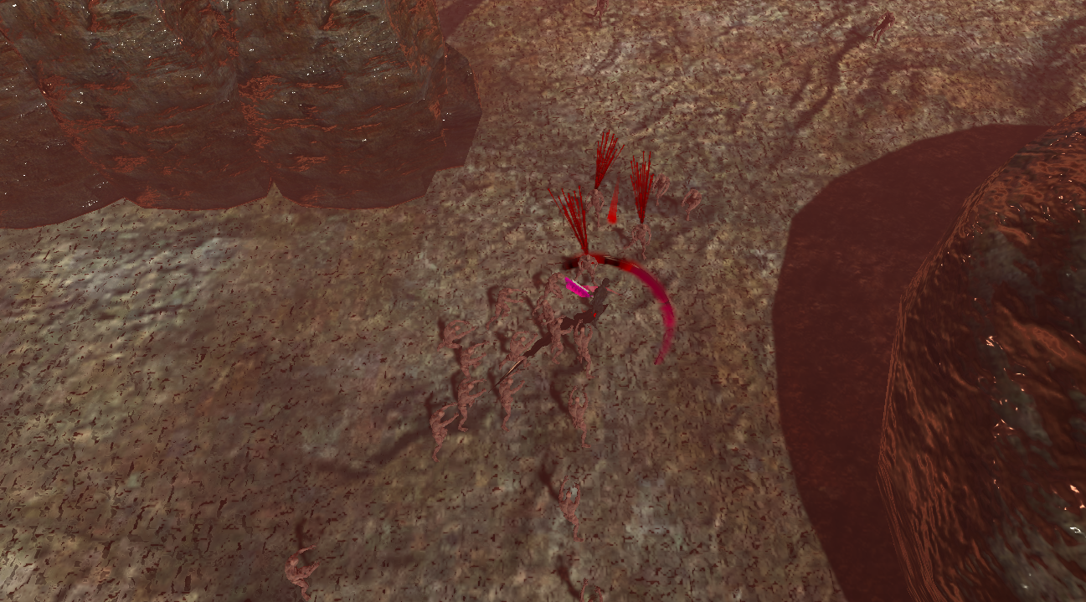

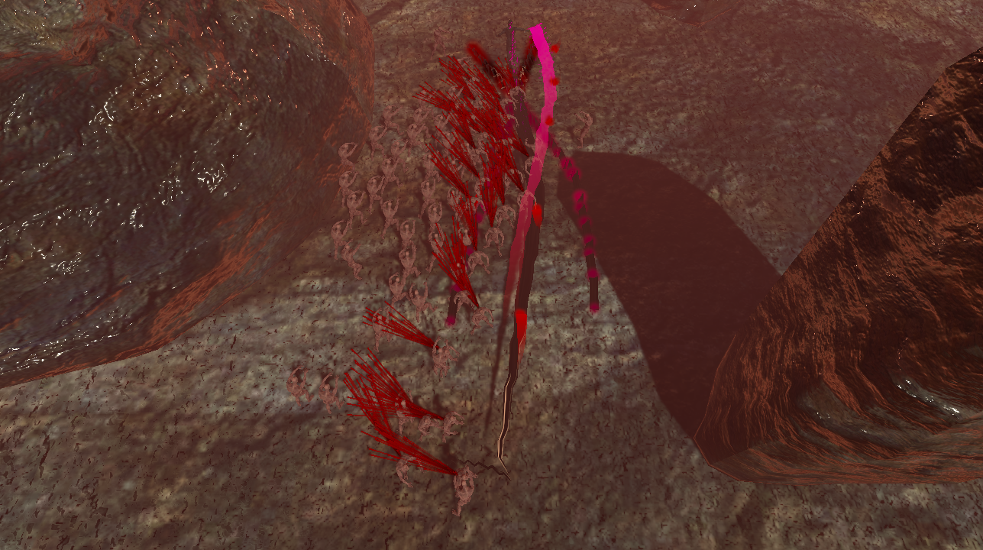

# 17 Wish List

#### Add More Enemies

Create a stronger, but slower “Hellien Slave” and a “Boss” enemy that spawns after the soldier kills a certain number of enemies.

#### Add Objectives/rewards

Reward player after a certain amount of kills i.e powerup.

#### Add Pause System

# Allow player to pause the game.

# 18 Bibliography

### 18.1 Personal Work

Reymond Pamelar. Shadow Trail [Personal Animation]. Created November 30, 2020, using Unity.

Reymond Pamelar. DashAttackPS [Personal Animation]. Created November 30, 2020, using Unity.

Reymond Pamelar. frontAttackSlash1 [Personal Animation]. Created November 30, 2020, using Unity.

Reymond Pamelar. frontAttackSlash2 [Personal Animation]. Created November 30, 2020, using Unity.

Samuel Hsu. Fear [Personal Background Song]. Created December 06, 2020, using FL Studio.

Samuel Hsu. Spooked Out [Personal Main Menu Song]. Created December 06, 2020, using FL Studio.

### 18.2 Outside References

Broken Knights Games(2020 November 28) InputHandler.cs [Source code].https://www.youtube.com/watch?v=-0GFb9l3NHM&ab_channel=BrokenKnightsGames

Broken Knights Games(2020 November 28) TopDownMovementHandler.cs [Source code].https://www.youtube.com/watch?v=-0GFb9l3NHM&ab_channel=BrokenKnightsGames

*Great Sword Walk* [FBX]. (2020 November 28). Maximo.com.

*Great Sword Jump Attack* [FBX]. (2020 November 28). Maximo.com.

*Great Sword Strafe* [FBX]. (2020 November 28). Maximo.com.

*Great Sword Run* [FBX]. (2020 November 28). Maximo.com.

*Ch44_nonPBR* [FBX]. (2020 November 28). Maximo.com.

*Character* [FBX]. (2020 November 28). Maximo.com.

*textures* [FOLDER]. (2020 November 28). Maximo.com.

Trees, Rocks, Bushes, Terrain textures. (2020 December 05). Unity Asset Store

*Ch30* [FBX]. (2020 December 08). Maximo.com.

*ZombieIdle* [FBX]. (2020 December 08). Maximo.com.

*ZombieWalk* [FBX]. (2020 December 08). Maximo.com.

*ZombieAttack* [FBX]. (2020 December 08). Maximo.com.

*ZombieDeath* [FBX]. (2020 December 08). Maximo.com.

Colorado Stark. (2017, February 10). Katana. Retrieved November 30, 2020, from https://opengameart.org/content/katana-2

Alexander. (2019, September 26). Cinematic Sonic Boom: Sound Clips From Orange free

Sounds. Retrieved December 08, 2020, from http://www.orangefreesounds.com/cinematic-sonic-boom/

The Aftermath Splash Logo. (2020, December 08). Logomakr.com.

Alexander. (2020, July 03). Charging Sound Effect: Best Online SFX Library For Media Projects. Retrieved December 08, 2020, from http://www.orangefreesounds.com/charging-sound-effect/

Will_leamon. (2018, December 01). Fleshy Fight Sounds. Retrieved December 08, 2020, from https://opengameart.org/content/fleshy-fight-sounds

AmazingMax. (2010, January 7). *AmazS.T.A.L.K.E.R.v.3.0* [TTF]. Retrieved December 08, 2020, from Dafont.com

Pixel Kitchen. (2010, January 7). *DonjonikonsRegular-VABy* [TTF].Retrieved December 08, 2020, from Dafont.com